DevOps Automation Phase
Steps:
- Installed ansible on the Master server and configured Slave server using SSH
- Updated host file and added Slave hostname
- vi /etc/ansible/hosts
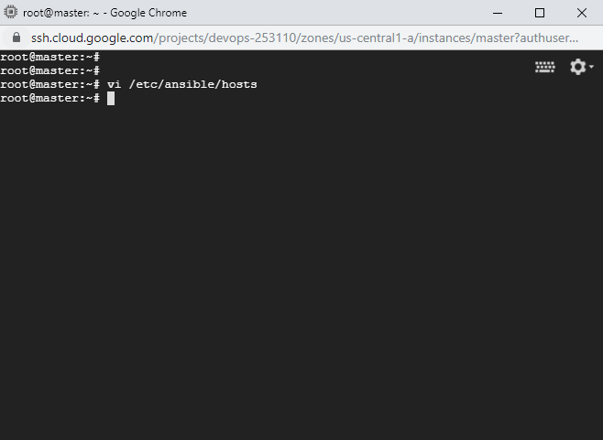

- Included Slave machine host name
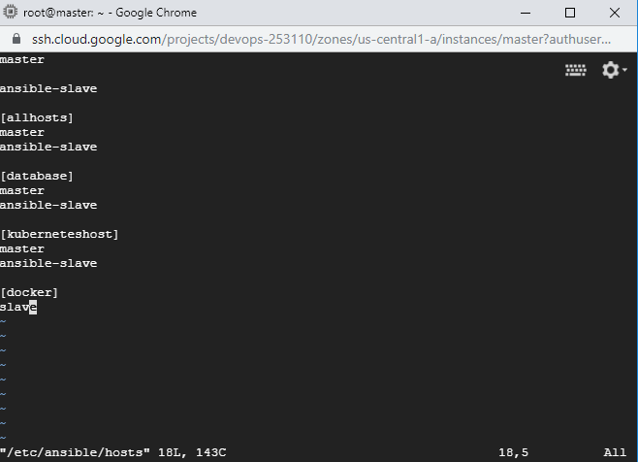

- Created a YAML file to install major modules such as GIT, JDK, Docker, Chromium browser etc.
- ---
- -
- become: true
- handlers:
- -
- name: "docker status"
- service: "name=docker state=started"
- hosts: docker
- tasks:
- -
- name: "Install Git"
- package:
- name: git
- state: present
- -
- apt:
- update_cache: true
- name: "Run update"
- -
- name: "Install JDK"
- package:
- name: default-jdk
- state: present
- -
- copy:
- dest: /home/edureka/
- src: /home/edureka/chromedriver
- name: "Copy chromedriver"
- -
- name: "Install chromium browser"
- package:
- name: chromium-browser
- state: present
- -
- name: "Install chromium driver"
- package:
- name: chromium-chromedriver
- state: present
- -
- apt:
- name: "{{ packages }}"
- state: present
- update_cache: true
- name: "Install packages that allow apt to be used over HTTPS"
- vars:
- packages:
- - apt-transport-https
- - ca-certificates
- - curl
- - gnupg-agent
- - software-properties-common
- -
- apt_key:
- state: present
- url: "https://download.docker.com/linux/ubuntu/gpg"
- name: "Add an apt signing key for Docker"
- -
- apt_repository:
- repo: "deb [arch=amd64] https://download.docker.com/linux/ubuntu xenial stable"
- state: present
- name: "Add apt repository for stable version"
- -
- apt:
- name: "{{ packages }}"
- state: present
- update_cache: true
- name: "Install docker and its dependecies"
- notify:
- - "docker status"
- vars:
- packages:
- - docker-ce
- - docker-ce-cli
- - containerd.io
- -
- command: "swapoff -a"
- name: "Disable swap"
- when: "ansible_swaptotal_mb > 0"

6. Created a Dockerfile to pull image and deploy code

FROM devopsedu/webapp
ADD website /var/www/html
RUN rm /var/www/html/index.html
cmd apachectl -D FOREGROUND

7. Pushed all these changes to GIT repo where code is added

Git repo : https://github.com/RaghavendraI/DevOps.git

8. Created two new pipeline jobs in Jenkins
a. One to install Docker, JDK etc using ansible
b. One to Start Containers and Perform Test

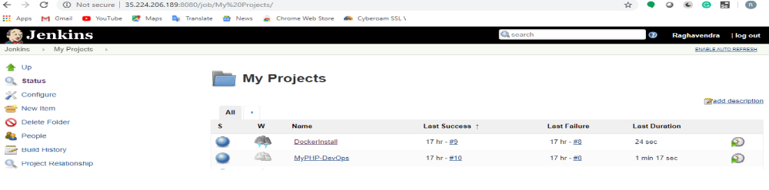

9. DockerInstall pipeline script:

node('master'){

deleteDir()
private final String PROJECT_PATH = pwd()

echo PROJECT_PATH

stage('Checkout code from git repo'){
git 'https://github.com/RaghavendraI/DevOps.git'
}

stage('Install docker using Ansible'){
dir(PROJECT_PATH + '/website/yaml'){
sh label: '', script: 'ansible-playbook docker.yaml'
//sh label: '', script: 'ls -ltra '
}
}
}

10 . MyPHP- DevOps pipeline script:

node('slave'){

stage('Install JDK,Docker using Ansible'){
build 'DockerInstall'
}

stage('checkout code'){
git 'https://github.com/RaghavendraI/DevOps.git'
}

stage('Run Dockerfile'){
sh label: '', script: 'docker build . -t appmain'
}

stage ('deploycontainer'){
sh label: '', script: 'docker run busybox'
sh label: '', script: 'docker stop $(docker ps -a -q)'
sh label: '', script: 'docker rm $(docker ps -a -q)'
sh label: '', script: 'docker run -it -p 8081:80 -d appmain:latest'
}

stage('Test the site'){

try{
sh label: '', script: 'java -jar Test.jar'
}
catch(Exception e){
sh label: '', script: 'docker rmi -f appmain'
sh label: '', script: 'docker stop $(docker ps -a -q)'
sh label: '', script: 'docker rm $(docker ps -a -q)'
}

}

}

11.
